PROGRESSIVE REPORT FOR FORUMCIV (Formerly known as

Forum Syd) PROJECTS2013-2022

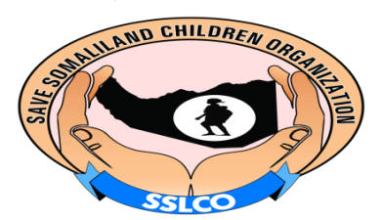
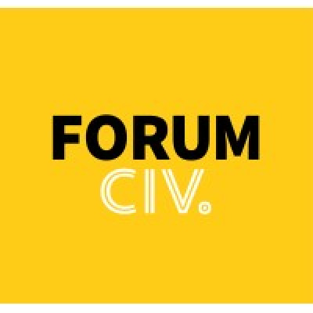

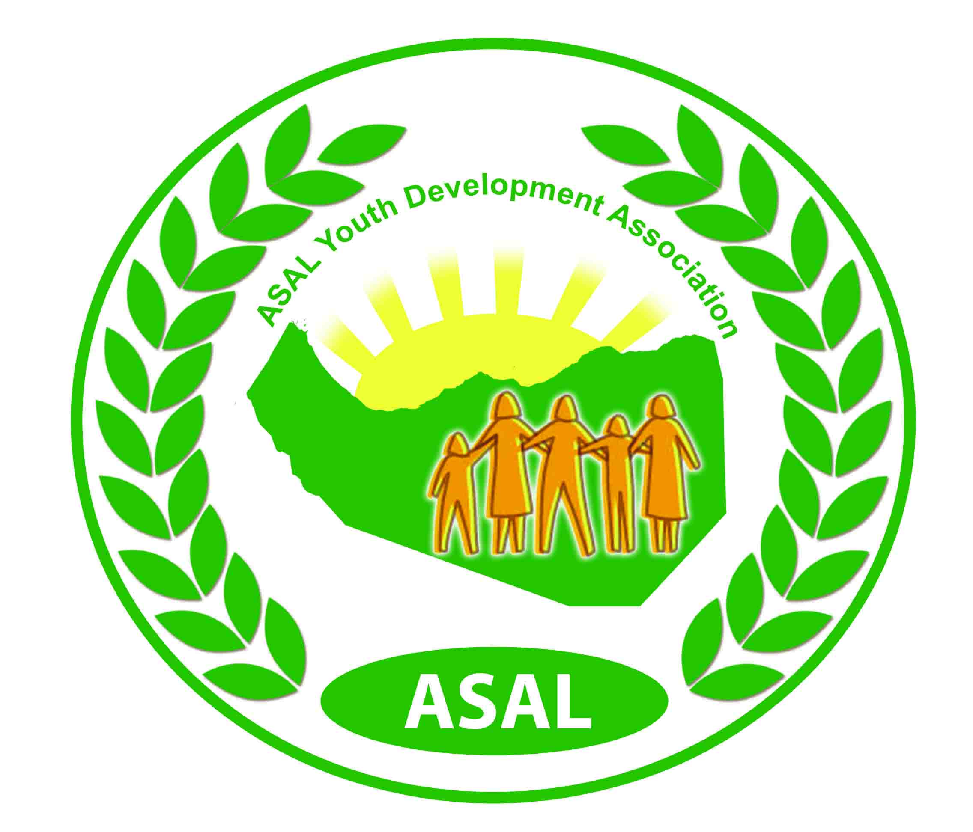

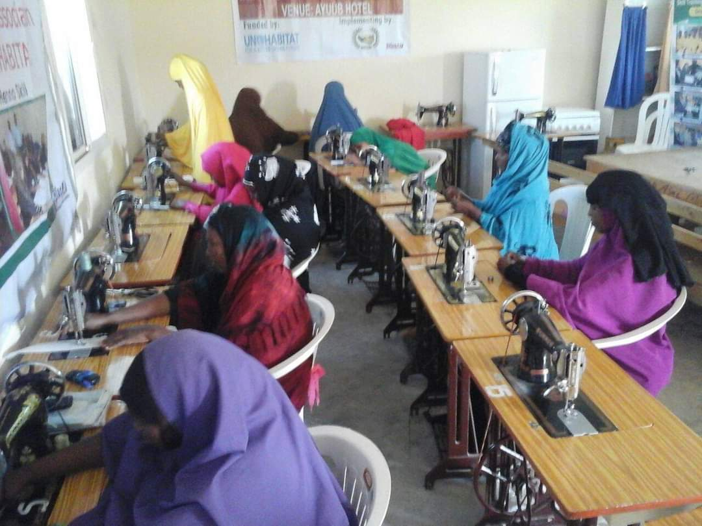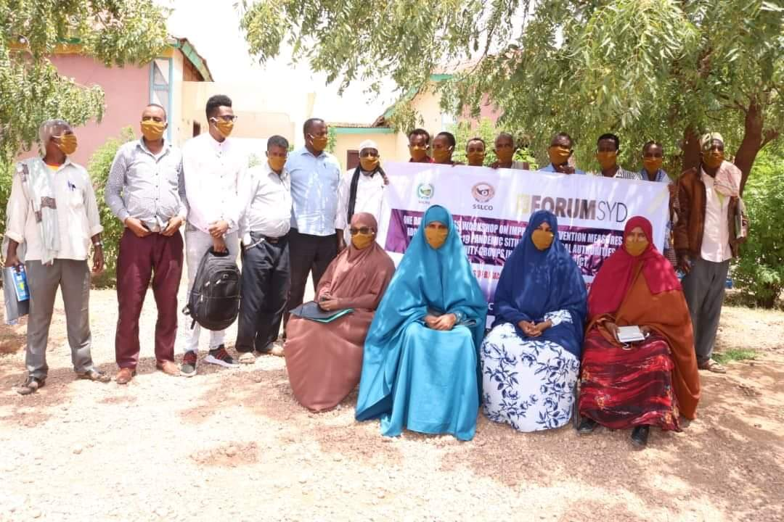

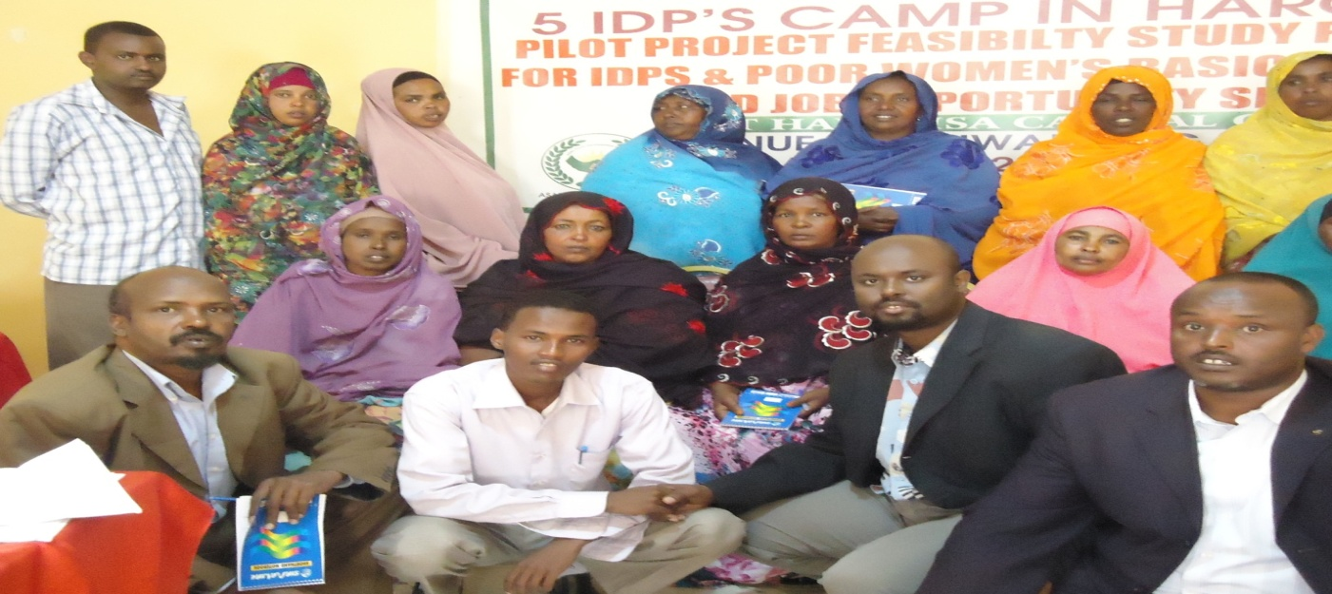
IDPs & Poor Women’s Basic Education and Job Opportunity Skills phase one
Project No: 300006112
Project Location: IDPs Camps at Hargeisa Capital City- Somaliland
Funding Agency: Forum Syd
Implementing Agency: Save Somaliland Children Org. with ASAL Youth Development Association
Duration: 1st Jan 2013 to 31th Dec 2013
Sector: IDPs & Poor Women
Beneficiaries: 200 Families
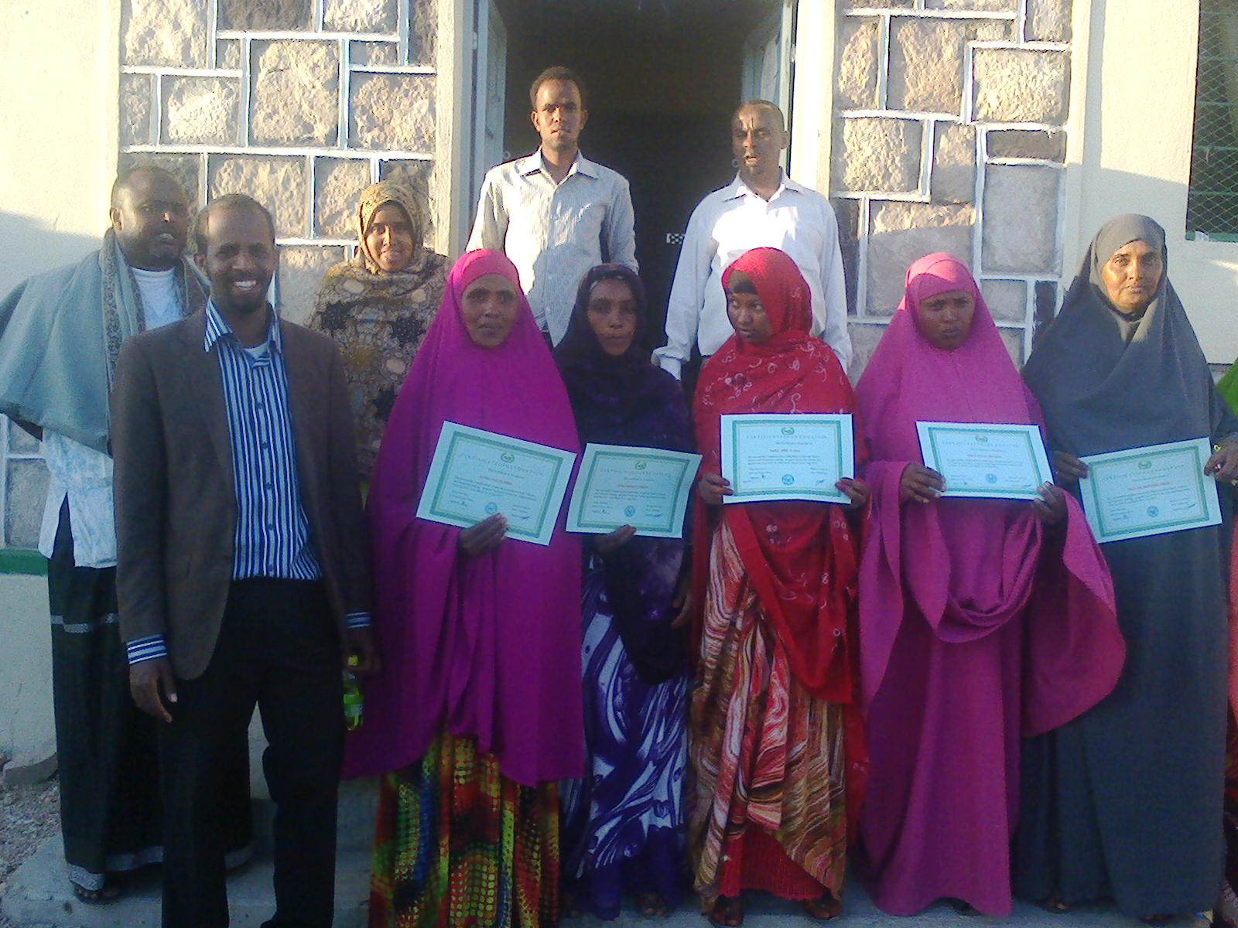
IDPs & Poor Women’s Basic Education and Job Opportunity Skills phase one was one year project funded by forum syd through Save Somaliland Children Organization which aims to empower marginalized and underprivileged women from the poor IDPs in Somaliland who have no access to education and vocational training services. This project targeted 200 unskilled and illiterate young women whose age between 15-32 years old that will come from the poorest and most vulnerable IDPs families living in 6 camps in Hargeisa. The project was based on the outcomes/results from 10 days Pilot Project Feasibility Study with group discussions, direct observation, identification of problems and prioritizing regarding “IDPs and Poor women’s Basic Education and Job Opportunity Skills, conducted on from 22th to 31th December, 2011. Funded by Forum Syd. The aim of this feasibility study workshop was to identify the best way of empowering these target women through provision of basic education and marketable skills training, so as they will be able to empower themselves by changing their living conditions through establishment of small scale businesses/activities that will change basic living conditions of their poor families. The project targets 200 unskilled and illiterate young women , whose age between 15 to 35 years old that will come from the poorest families in IDPs.
Therefore, the project embowered these targeted women trough provision of basic education and job opportunity skills. After provided these basic education and skills training to these poor women, they abled to empowered themselves by changed their living conditions through establishment of small scale businesses that changed basic living conditions of their poor families. The project targeted beneficiaries was 200 Families during 01 January 2013 to 31 December 2013.

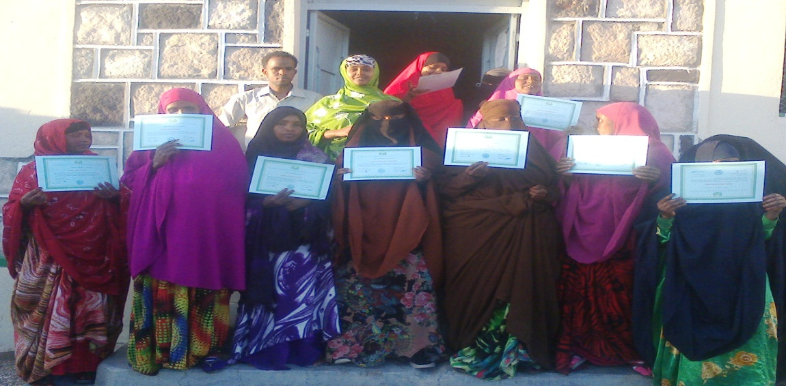
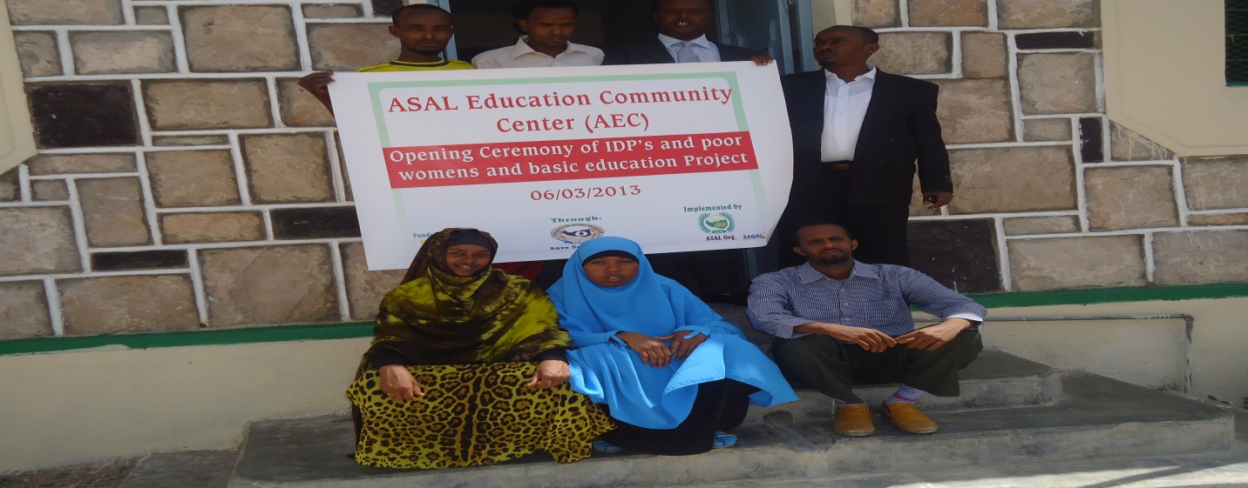

IDPs & Poor Women’s Basic Education and Job Opportunity Skills phase two
Project No. 300006453
Project Location: IDPs Camps at Hargeisa Capital City- Somaliland
Funding Agency: Forum Syd
Implementing Agency: Save Somaliland Children Org. with ASAL Youth Development Association
Duration: 1st March 2014 to 31th Jan 2015
Sector: IDPs & Poor Women
Beneficiaries: 200 Families
ASAL’s project IDPs, poor women’s basic education and skills training phase II has been an extension from the preceding year of 2013. In 2014, the project started in April with more super implementation strategies. 200 girls between the ages of 15-35 years attended at vocational training skills on tailoring and catering that ensured over 82% achievement of the year’s plan with 91% effectiveness of implementation. The tailoring skills is at first stage level and together with our other sources ASAL will further provide tailoring level 2 on product design, marketing and formation of women business entities. The trainees already started to produce marketable clothing items and generated an income from the sales of what they produce. 60 students were registered at Literacy classes that make almost 96% successful achievement on ASAL’s literacy programme plans in 2014. Business counselling provided to all skills trainees and access to market promoted. Staff capacity building conducted for teachers, program and administration staff. Tailoring and cooking utensils procured for women businesses in order them to run.

Teaching and learning materials were developed and revised. Staff and stakeholders’ capacity building was conducted for 24 members from 6 IDP camps in 2 times. Community based sensitisation workshops were organized in the area of project sustainability and 30 participants from CECs, MoE and partner organizations educated. Knowledge on HIV/AIDS, Human rights and environment promoted in the target areas and IDP camps through mainstreaming workshops. Coordination and organizational networking continued and strengthened through stakeholders’ involvement and representation of the project and our organization at government and NGOs coordination units.
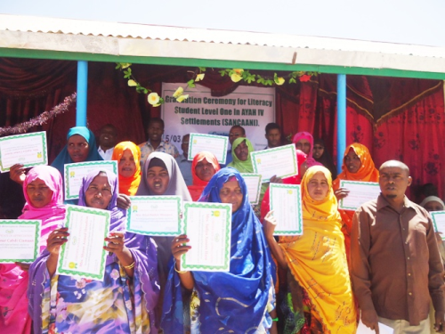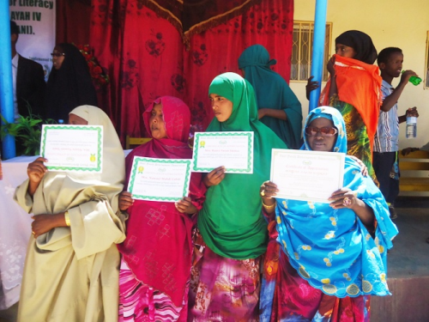
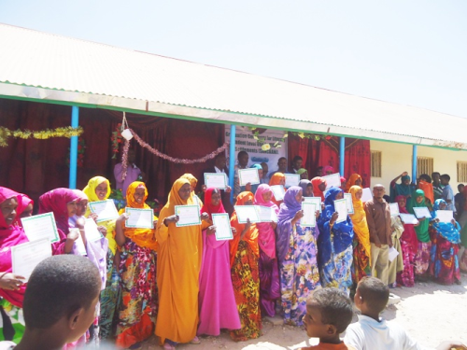

Democracy and Women’s Human Rights Promotion
Summary of progress report of democracy and women’s Human rights promotion project 2015
- Project Goal and Objectives:
The Project “Democracy and Women’s Human Rights Promotion” has been implemented by ASAL Youth Development Association and funded by FORUM SYD through Save Somaliland Children Organization. Location of the project was Hargiesa and the neighboring districts. The overall goals and objectives of the project was to intended to contribute promotion of democracy and women’s human rights protection by ensuring that the women have acquired access to security, justice, education, the rights to participation in decision making and minimize societal circumstances against women and girls.

While the specific objectives of the project was
- To enhance awareness of targeted groups on promoting democracy and human rights protection.
- To improve women’s human rights protection by increasing access to security, justice and participation of women and girls in decision making process.
- To Increase human rights awareness from community grass-root both public & private sector, in order to facilitate creation of an democratic environment and equal participation of the decisions in all levels.
- To enhance community activism for gender and social justice by reducing societal circumstances against women & girls such as low social status, lack of ownership and access to productive asset, limited education and participation in decision making, GBV, discriminative customs, early and forced marriages.

Achievements
The project which was duration of 12 months (1st January to 31st December, 2015), the size of primary target groups of the project was a total of 14,000 individuals (12,000 women & youth, 2,000 men), while the size of secondary project target groups were a total of 300,000 individuals (100,000 women & youth, 200,000 men). However, during implementation period, the project has made remarkable achievements towards project results and impacts so far made, these includes

- The project has employed 9 persons as project staffwhich consist of 1 project officer, 1 Accountant, 5 community mobilizers, 1 cleaner and 2 watchman with based on human resources policy of the organization with one laptop computer for project documentation.
- On the other hand, the project assisted to prepare and translate into English and Somali language for 5 training manuals on democracy & human rights promotion
- Also, this followed by printing and distributed different IECT materials including (16 bill boards, 2388 leaflet & stickers, and 2961 brochures).
- Similarly, the project was supported to train 200 representatives from community service providers and 240 members from community committees of 10 IDPs Camps on the issues of early and forced marriage, domestic violence, and other topics related to the democracy and human rights protection.
- Also, the project was trained for 100 participants from young activists groups on their fundamental rights and freedoms, life skills, coaching, self-presentation, and finally, 8 youth activist groups were established in order to carry advocacy messages for youth issues.
- In addition that, the project assisted to organize 3 plenary discussions by influential target groups (religious leaders and elders) which reached and sensitized a total of 108 representatives from the elders & religious leaders on promoting democracy and human rights protection
- Likewise, the project supported panel discussion on promoting democracy and human rights protection which about 144 participants from community members and other activist groups were attended, for the aims of improving community activism for gender and social justice.
- Also, it was organized and supported about 48 members from 12 community committee centers, in order to mobilize themselves and discuss various issues related to the democracy and human rights protection, at the same time, the committees were produced 12 community human rights based agendas.
- The project improved public education and awareness rising around democracy and women’s human rights protection by carried out 2 outreach sensitization programs on various topics on human rights and democracy through stage drama presentations and participation of celebration events, which more than 30,000 individuals were sensitized and got information and slogans about democracy and human rights protection respectively.
- Besides, the project has also trained 40 representatives from Community service providers on legal aid support and the importance of it in terms of justice system and to equitable access to justice by the whole community.
- Moreover, the project has provided legal aid support for 15 vulnerable victims from IDPs by legal consultant.
- Finally, the project has resulted produce and broadcast 3 media documentary-films of each 30 minutes on the focus of women’s human rights protection and deeply rooted the negative stereotype against social, political and economic imbalance of gender among the community. This followed by media coverage of the issues of democracy and women’s human rights promotion through TV programmers and other social media channels.

Promote Participatory, Good Governance, Human Rights and Democratic System of the Country-2016-2018

Project number: 300007042
Save Somaliland Children Organization (SvEO) and local partner ASAL Organization (LEO) have together implemented a Project of ” ASAL Youth Development Association has been implemented a three years project entitled “promote participatory, good governance, human rights and democratic system of the country 2016-2018” which funded by FORUM SYD & Save Somaliland Children Organization. The aim of the project was strengthened on democracy, human rights and good governance, so as to lead participatory, representative and inclusive political and government institutions. Also the project aimed to consolidate inclusive and accountable democracies to advance freedom, dignity, political engagement and well informed citizens, active CSOs, organized labour, independent and open media in Somaliland. Target beneficiaries of the project were local authorities, CSOs, political parties, media & community grass-roots.

Promote Participatory, Good Governance, Human Rights and Democratic System of the Country-2016-2018 (Year 2016)
this is a first annual report of the project (1st January-31st December, 2016). During this period, the project has achieved remarkable achievements and positive results. At the initial stage, community mobilization and project familiarization workshop to the target beneficiaries and other stakeholders was done. Also the project staff those consists of one Project-Officer, one Accountant, 3 Supervisors, one Cleaner & two Watchmen were employed with based on Human Resources Policy of the organization. Secondly, it was prepared and translated 5 trainingmanuals on democracy, HRs & good governance in to English/Somali Language. This followed by trained 150 service providers of local authorities, regional administration, CSOs, local courts & media groups for civic education, adaptation of good governance, running of transparency and accountability. Also, leaders of political parties trained and sensitized on good governance, political dialogues, and tolerance to competitive democratic process during political campaigns. In addition, it was sensitized 320 representatives of government institutions, community elders, religious leaders & CSOs mainly from IDPs settlements and they got information about democracy, human rights and democratic governance system. Approximately 75,000 individuals were got awareness on various topics on human rights, democracy and good governance. Also 80% of the target community raised their competence to practically demand for accountability from the elected leaders.At least 4 media programs were broadcast via mass media channels and more than 600, 000 individuals reached and got messages on democracy, human rights and freewill. Similarly, the project created new platform discussions among community groups and their leaders for interface and engage each other on matter of good governance and political accountability. Again, the Level and space of participation for the special interest groups (youth, women, disability people & other ethnic minorities) were increased in the democratic governance and policy making process. About 1000 pieces of quarterly magazine on democracy, HRs and good governance issues were published and distributed to the public & private centres. Six ASAL staff personnel were trained on PCM, human rights, democracy, accountant & report writing skills (in & outside of office). Also it was produced 10 community based agendas on democracy, HRs and freewill at community level. Equally, 10 government offices, 5 police stations, 6 community committees centres’ meetings, 5 health-posts, 4 local courts & 10 public schools were routinely visited for monitoring how they deliver the service to the community and to create mass awareness on democracy & freewill
Training workshop on democracy and Human rights for the service providers. (Local governments, Regional Administration, CSO, Courts, Local NGOs, private sectors, media .)
Visit routinely to the government offices, community leaders’ meetings, local courts, mosques, schools and community centres, health posts ,police stations for monitoring how they deliver the service to the citizens
Public Forums dialogue on democracy and good governance, 3 sessions and broadcast via mas media.
Preparation and translation of teaching materials on democracy & human rights
Awareness raising sessions on different topics on democracy, Human Right and good governance at community level ,( Rountily)
Outreach sensitization program on various sessions on human rights and democracy (Stage drama and participation of celebrations)
Plenary discussions among influential groups including religious leaders, and community elders, for promoting democracy and freewill
Publish Quarterly hope Magazine for Democracy, good governance and human rights issues

Promote Participatory, Good Governance, Human Rights and Democratic System of the Country-2016-2018 (Year 2017)
According to the achievements, progress and results achieved during the reporting period of the project (1st January-31st December 2017). Actually, ASAL Youth Development Association (LEOs) has successfully done all planned goals and sub-goals of the project and greaten met for the expected results/outcomes of the project. These includes
- At initially, the project sensitized for 120 representatives from target beneficiaries and other concerned stakeholders. The participants were got information about project priorities/objectives, progress of first phase and second phase work plan. At same time, project ownership promoted
- The 5 training manuals and 1000 pieces of quarterly magazine were prepared and published in the public & private centers to increase education on democracy, good governance and human rights.
- Almost, 75,000 individuals were sensitized on various topics on human rights, democracy and good governance through various outreach awareness raising programmers at community centers.
- Also about 8 national and international celebration events organized to create mass awareness and over 4,800 individuals were got reached with democracy and human rights slogans.
- Over 150 service providers including local government, regional administration, local courts, CBOs and media groups were trained on democracy and human rights.
- Different media programs broadcasted and disseminated via social media channels and various IEC materials printed to reach over 300, 000 individuals and got messages on democracy, civic education, human rights and freewill.
- Similarly, 75,000 individuals sensitized on various topics on human rights, democracy and good governance during outreach awareness raising programmers.
- In the same way, 200 from local authorities, community elders, religious leaders and CSOs were trained and sensitized on good governance, human rights and civic education to promote transparency and accountability among the community.
- Again, 12 community based agendas on different of democracy, HRs and freewill were produced at community level.
- More than, 12 community centers and government offices were routinely visited to sensitize and engage them on the matters on democracy, human rights and accountability of service delivery of the community.
- Additionally, it was established a well equipped center of excellence for democracy, human rights and good governance as research and info centre. As the same time, introducing session was conducted to familiar different community groups about the key functions and priorities of the center
- Significantly, the issues of democracy, human rights and good governance were advocated to nationalize and put in the public decisions and programs as well.
- Also, 10 staff personnel of (LEOs) were capacitated in the areas of PCM, human rights, democracy, report writing & accountant procedures.

Promote Participatory, Good Governance, Human Rights and Democratic System of the Country-2016-2018 (Year 2018)
Therefore, through the three (3) years financil support from FORUM SYD to Save Somaliland Children Organization and ASAL Youth Development Organization, the community in somaliland has felt some desired changes after they got sensitization or an awareness of thier basic rights and build capacity of the community to influence Duty-bearers and holding or demanding transparent and accountability of thier elected leaders.
The support of FORUM SYD facilitates an establishment of new platform system which the citizens and their leaders can interface and engage each other on matters of good governance and democracy issues. As results, this change created a space of participation for the community in some decisions and policy making process. The activities of the program in 2016-2018 has strengthened the capacity of 600 service providers from public and private institutions to consolidate inclusive and accountable democracies to advance freedom, dignity and social development. Also the intervention has empowered and build the competence of 450 community leaders, CSOs and Activists (100 committees/elders, 150 women, 100 youth (girls & boys) and 50 activists) to represent thier communities in participation of political decisions affecting thier livelihoods and as well as to create a neutral environment that the democracy and freewill to be a state centric approach.
Both an internal and external monitoring and evaluation (project results/changes on December 2018) conducted by SSCO (SvEO) and ASAL (LEO) showed that the role of community grass-roots are more likely recognized as important element of good governance and democratization process of the country. The evaluation also highlighted that the project has contributed an increased people’s (right-holders) capacity for claiming thier basic rights and proposing essential services to the local authorities.
One of the unexpected outcome/change of the project is that the local authorities of two districts (sahil&salel) have started transparent and decentrilization of thier services/programs by publishing information about income and expenses of thier budgets, and this facilitated participation of the community at village/district level. So that, the project goals were greater achieved.
Strengthening Democratic and Good Governance in Somaliland Phase-II 2019
Project number: 300008187
According to the results and tangible changes achieved during the project period, the most of the goals and sub-goals of the project was successfully achieved as planned. These include the external evaluation for the previous implemented project of “Promotion, on democracy, good governance and human rights development in Somaliland” (300007042) in 1st January to 31st December 2019. This followed by capacitated and trained of 150 members (90 women & 60 men) from community committees and elders on human rights monitoring, case management and referral pathway of GBVs cases. Also the project was reached and sensitized over 900 individuals on civic education and constitutional learning
These efforts have together sustained the exist results and created synergyies between this project and previously development interventions, where the target communities have better understood the principles of democracy and good governance including public policy, elections and accountability of government institutions. As results, some of the members of community committees, Youth and women activist have started discussions on the rights of marginalized groups and and advocacy for gender equality and non-discrimination at gross-root level.
Similarly, the project was capacitated and trained of 150 members (90 women & 60 men) from community committees and elders on human rights monitoring, case management and referral pathway of GBVs cases. Where over 900 individuals were reached and sensitised on civic education and constitutional learning. Therefore, the engagement of various target groups revolve around awareness-raising on civic education and constitutional learning has been sustained previous project’s results, contacts through different public dialogues, plenary discussions done during the project.
Finally, the project activities have together increased community’s awareness and understanding on democratic governance and public policy issues including elections and accountability of government institutions. At the same time, the discussions and advocacy on the rights of marginalized groups were promoted at gross-root level which contribute the engagement of public and private actors for adopting gender equality and non-discrimination principles at all levels.
During the first two months of the project period (January-February 2019), an external evaluation was conducted. The objective of the evaluation was to assess and provide relevant findings, lessons-learnt and recommendations for the project of “Promotion, on Democracy, Good Governance & Human Right Development Project (300007042), which implemented by ASAL and SSCO in Somaliland during 2016-2018.The evaluation was focused on the relevance, effectiveness, impact, sustainability, partnerships, agreement compliance and as well as ASAL’s general capacity.
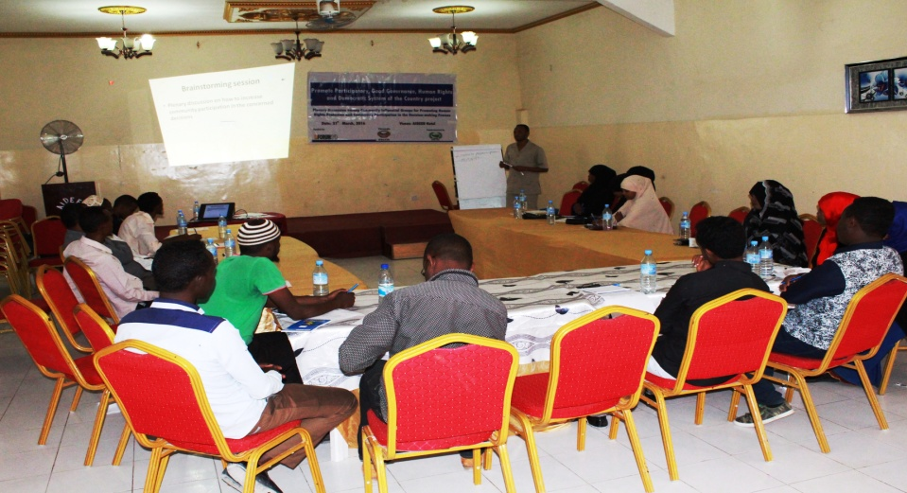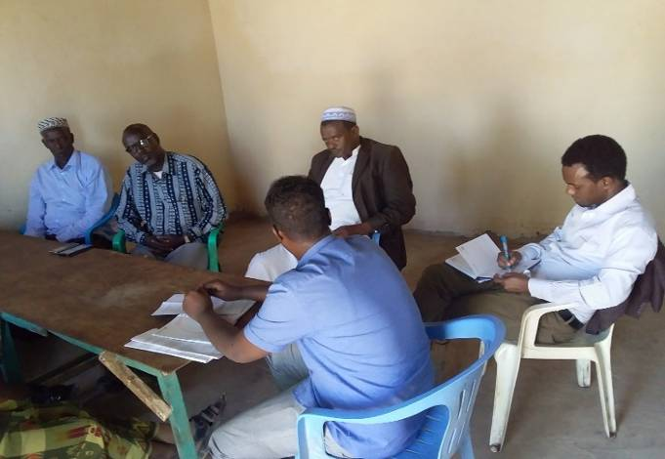
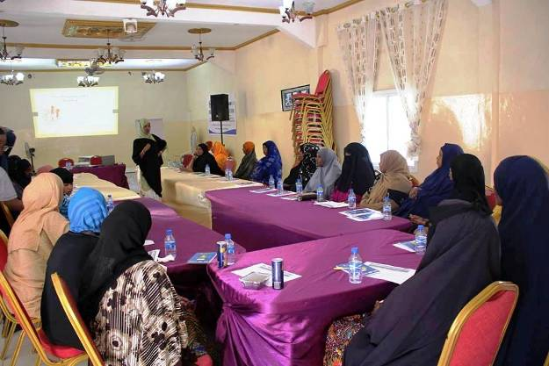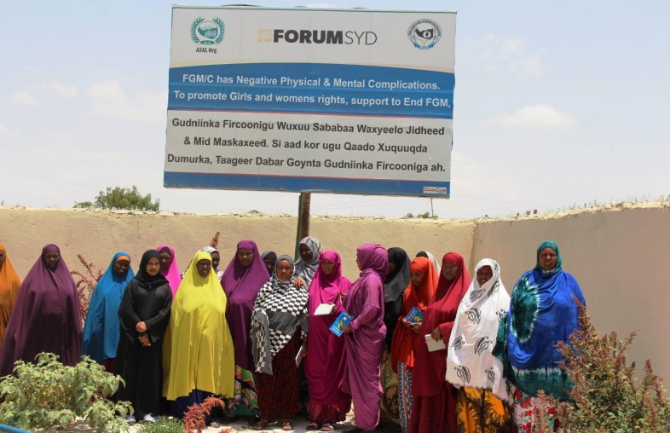

Promote Participatory, Good Governance, Human Right and Democratization process of Somaliland phase two 2020-2022
ASAL Youth development Association (LEO) with collaboration of Save Somaliland Children Organization (SvEO) have together implementing a three-year project on “Promote participatory, Good Governance, Human rights, and democratization process of Somaliland (Phase – II)” which funded by ForumCiv on 1st January-2020 to 31st December-2022.
The overall goal of the project was promoted a vibrant civil society that advocates for a peaceful andinclusive society, sustainable development and improved access to justice for all in Somaliland. Theproject is composed of comprehensive activities with the target groups to realize greater democraticprocess and human rights protection. And the overall objective are aimed to increase community’s awareness and understanding of their civic rights and constitutional obligations, where the CSOs and existed community level working groups will be capacitated and facilitating their legitimate space for policy dialogues, self-reflection and influencing of critical public issues, political dialogues and other policy-making decisions that affecting their livelihoods.
The project is composed of comprehensive activities with a whole host of target groups such as rights holders, civil society actors and duty-bearers to realize greater democratic process and human rights protection. The target groups of the project are the whole host community groups(rights-holders) The civil society organizations (CSOs) and Local authorities (Duty-bearers) and the total direct beneficiares of the project were 18000 individuals (14000 women and 4000 men) while the total indirect beneficiaries were 360,000 individuals ( 144,000 women and 18,000 men)
Therefore, during second year of the project for three years project on “Promote participatory, Good Governance, Human rights, and democratization process of Somaliland (Phase – II)” from 1 January – 31 December 2021) the project has been successfully covered and done what theysaid to do as aoutline/ planned in the project goal and risk matrix and has reached a tangible result and produced a significant impact as expected to the target beneficaries. There is no any deviation occurred during the implementation for the project.
Promote Participatory, Good Governance, Human Right and Democratization process of Somaliland phase two 2020-2022 Year One (2020)
The Somaliland is being struggling to sustain relative peace, political stability and full functioning of state organs after gained its independence from the unified Somalia in 1991. Since then, the country has built a sustainable democratic leadership process, included constitutional referendum held in 2001, and establishment of multi-party political system and as well as held several elections of presidential, parliamentary and local councils during 2005-2019.
However, the country has faced a lot of challenges regarding maintaining the nascent democratic process of Somaliland. The Socio-cultural nature of the community, including powerful Clan-based systems, tribalism and politicization of clan-identity are the most difficult barriers that devastated the democracy and human rights issues of the country. In addition to, the weak public institutions and absence of comprehensive constitutional rights education are also recognized to be the root causes of poor democratic system in Somaliland.
Most of CSOs and Citizens have no space and legitimate influence for political dialogues and policy decision-making process that affect their livelihoods. Often the vulnerable groups living under marginalized conditions have faced high level of discrimination, exploitation, inequalities and exclusion of political process and government institutions. The duty-bearers largely do not understand the rights-based approach and their obligation to fulfill the public trust to deliver inclusive and equitable basic services in a transparent way.
Therefore, to address the above mentioned problems, ASAL Youth Development Association (LEO) with collaboration of Save Somaliland Children Organization (SvEO) has been implemented a three-years project on “Promote Participatory, Good Governance, Human Right and Democratization process of Somaliland phase two” from 1st January 2020 to 31st December 2022. The project which was the second phase of joint development work for "strengthening democracy, good governance and human rights protection of Somaliland" that ForumCiv has been funded since last 5 years (2016-2020).
The overall goal of the project was promoted a vibrant civil society that advocates for a peaceful and inclusive society, sustainable development and improved access to justice for all in Somaliland. The project is composed of comprehensive activities with the target groups to realize greater democratic process and human rights protection. The target groups of the project are the whole host community groups (Rights-Holders), the civil society organizations (CSOs) and local authorities (Duty-bearers).The total direct beneficiaries of the project were 18,000 individuals (14,000 women & 4,000 men).While 360,000 individuals (144,000 women & 18,000 men) were benefited the project indirectly.
However, during the first year of the project (1st January-31st December 2020), ASAL Youth Development Association (ASAL) has been successfully done what they said to do as outlined in the Project-Goal-and-Risk-Matrix, and significantly produced most of the expected impacts. As all of you aware of, COVID-19 pandemic cases tested positive in Somaliland and Somalia during the implementation period for the project. Due to this risk Somaliland is in locked down situation. People are ordered to stay at home and not to come together in markets, teashops and public places. All employees are free from working places. During crisis situations, ASAL Youth Development Association communicated and shared situations caused by COVID-19 with Save Somaliland Children Organization (SvEO), ASAL Youth Development Association, due to unforeseen circumstances related Covid-19 suggested accordingly for this reason to reviewed and changed some activities in project related to the current circumstances, after thorough analysis and also Save Somaliland Children Organization (SvEO) shared and convinced ForumCiv for project activities changes, The request was accepted and ASAL senior program managers planned changes of mid-term work plan to identified and justified what we can do and what we cannot do and justify why we cannot do it in this locked down situation.
    - Launching Workshop to introduce target beneficiaries and concerned stakeholders about project objectives and priorities
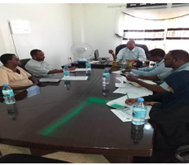
From 10th-18th Feb 2020, ASAL has conducted different orientation meetings and information sharing sessions on introducing the target beneficiaries and concerned stakeholders about project’s objectives, scope and priority areas. The sessions were take place in Hargeisa and over 100 people from government institutions, LNGOs, INGOs, community level working groups and media were received the introduction and information about the project through launching meetings and mass media channels.
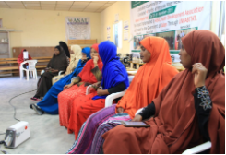
Similarly, good governance& Anti-corruption commission (GGACC) have been separately introduced the project’s objectives, target groups and priority areas. They have emphasized the importance and benefits of the project to the target beneficiaries and particularly the improvement of good governance system and democratic process in Somaliland.
In order to increase widely dissemination of the project’s information and number of people reached, ASAL project-manager and other focal-point personals have been shared and presented introduction about the project to the participants those attended the workshops and coordination meetings organized by government institutions and humanitarian organizations.
Print and distribute various Articles and IEC materials that containing information and slogans of constitutional rights (booklet, leaflets, brochures, bill-boards, stickers & banners)
In order to increase the awareness of the community and target beneficiaries of the project’s key messages, ASAL has printed and distributed different IEC materials that containing information and slogans of constitutional rights. These include 120 booklets, 5000 leaflets, 300 brochures/stickers, 12 bill-boards and 120 banners.

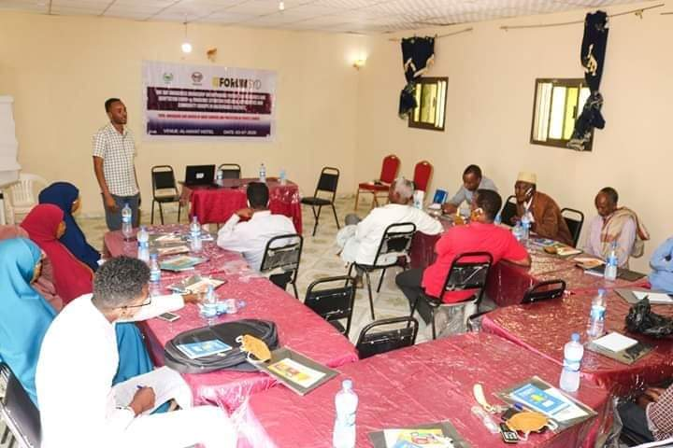

Promote Participatory, Good Governance, Human Right and Democratization process of Somaliland phase two 2020-2022 Year Two (2021)
The project has made significant impacts/ changes in the partner organization and implemented the project has made fruitful difference and tangible results, according to the results achieved, it’s clear that the goals of the project has been successfully realized greater and met expected results of the project, and target beneficiaries as well. The project has increased community awareness and understanding of their civic rights and constitutional obligations, it enhanced awareness and education of the community and got information about their constitutional rights in equal participation of political dialogue, decision making process and demanded accountability of their duty bearers.
The project has directly capacitated 6,000 people (4,500 women and 1,500 men) in order to realize greater democratic process and human rights protection through capacity building trainings, public forum dialogues and different various coordination meetings. While the project indirectly sensitized and reached 120 individuals (48,000 women and 6,000 men) through via mass media and awareness raising sessions, TVs and radio programs.
Also, the project has resulted to strengthen the capacity and coordination of existing CSOs platforms and local authorities’ agencies who have a role play on policy advocacy, democracy, and good governance issue. As results, the effective coordination and strong social contract between local authorities and their citizens promoted and contributed to the formulation of more responsive and more effective services delivery at community level. Whereas the project has created effective taskforce that continues national coordination meetings that influencing policy dialogue, political dialogues and other policy making decisions that effecting their livelihoods. This followed promoting the principle of good governance and democratization process of the country.
Finally, the project significant impact government institutions and political leaders and their decision making processes, as result ministry of education and ministry parliamentary relations and constitutional affairs succeeded to add education curriculum civic and constitutional learning courses in primary/ intermediate and secondary schools and now it’s the part of curriculum of the country.
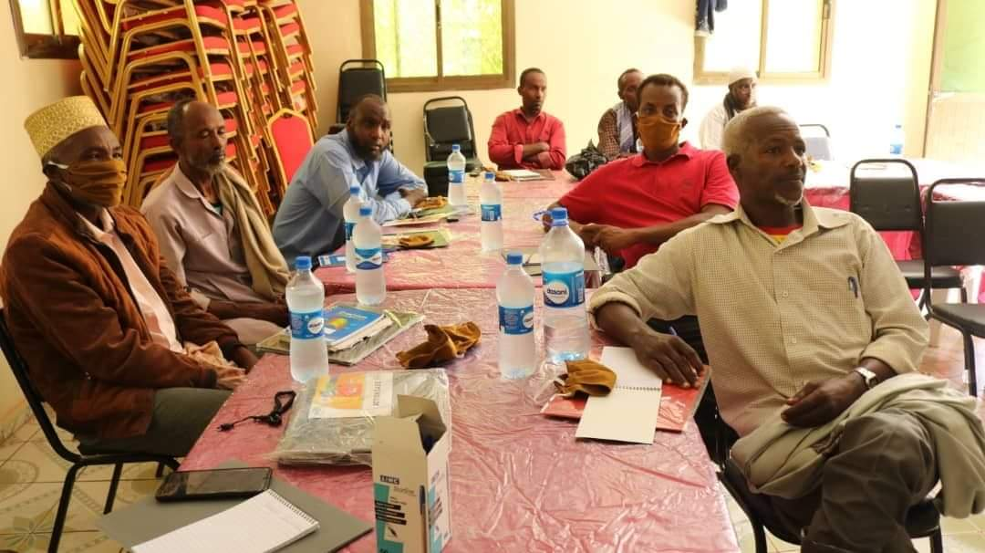

Promote Participatory, Good Governance, Human Right and Democratization process of Somaliland phase two 2020-2022 Year Three (2022)
The project has made significant impacts/ changes in the partner organization and implemented the project has made fruitful difference and tangible results, according to the results achieved, it’s clear that the goals of the project has been successfully realized greater and met expected results of the project, and target beneficiaries as well. The project has increased community awareness and understanding of their civic rights and constitutional obligations, it enhanced awareness and education of the community and got information about their constitutional rights in equal participation of political dialogue, decision making process and demanded accountability of their duty bearers.
The project has directly capacitated 6,000 people (4,500 women and 1,500 men) in order to realize greater democratic process and human rights protection through capacity building trainings, public forum dialogues and different various coordination meetings. While the project indirectly sensitized and reached 120 individuals (48,000 women and 6,000 men) through via mass media and awareness raising sessions, TVs and radio programs.
Also, the project has resulted to strengthen the capacity and coordination of existing CSOs platforms and local authorities’ agencies who have a role play on policy advocacy, democracy, and good governance issue. As results, the effective coordination and strong social contract between local authorities and their citizens promoted and contributed to the formulation of more responsive and more effective services delivery at community level. Whereas the project has created effective taskforce that continues national coordination meetings that influencing policy dialogue, political dialogues and other policy making decisions that effecting their livelihoods. This followed promoting the principle of good governance and democratization process of the country.
Finally, the project significant impact government institutions and political leaders and their decision making processes, as result ministry of education and ministry parliamentary relations and constitutional affairs succeeded to add education curriculum civic and constitutional learning courses in primary/ intermediate and secondary schools and now it’s the part of curriculum of the country.
The project has made significant impacts/ changes in the partner organization and implemented the project has made fruitful difference and tangible results, according to the results achieved, it’s clear that the goals of the project has been successfully realized greater and met expected results of the project, and target beneficiaries as well. The project has increased community awareness and understanding of their civic rights and constitutional obligations, it enhanced awareness and education of the community and got information about their constitutional rights in equal participation of political dialogue, decision making process and demanded accountability of their duty bearers.
The project has directly capacitated 6,000 people (4,500 women and 1,500 men) in order to realize greater democratic process and human rights protection through capacity building trainings, public forum dialogues and different various coordination meetings. While the project indirectly sensitized and reached 120 individuals (48,000 women and 6,000 men) through via mass media and awareness raising sessions, TVs and radio programs.
Also, the project has resulted to strengthen the capacity and coordination of existing CSOs platforms and local authorities’ agencies who have a role play on policy advocacy, democracy, and good governance issue. As results, the effective coordination and strong social contract between local authorities and their citizens promoted and contributed to the formulation of more responsive and more effective services delivery at community level. Whereas the project has created effective taskforce that continues national coordination meetings that influencing policy dialogue, political dialogues and other policy making decisions that effecting their livelihoods. This followed promoting the principle of good governance and democratization process of the country.
Finally, the project significant impact government institutions and political leaders and their decision making processes, as result ministry of education and ministry parliamentary relations and constitutional affairs succeeded to add education curriculum civic and constitutional learning courses in primary/ intermediate and secondary schools and now it’s the part of curriculum of the country.

Print and Distribute IEC Materials that Containing information and slogans about Constitutional rights and Good Governance

In order to improve and increase further awareness about good governance and constitutional rights of the community and project key stakeholders, ASAL organization has been printed and distributed various articles and IEC materials including (2000 stickers, 12 bill-boards and banners).

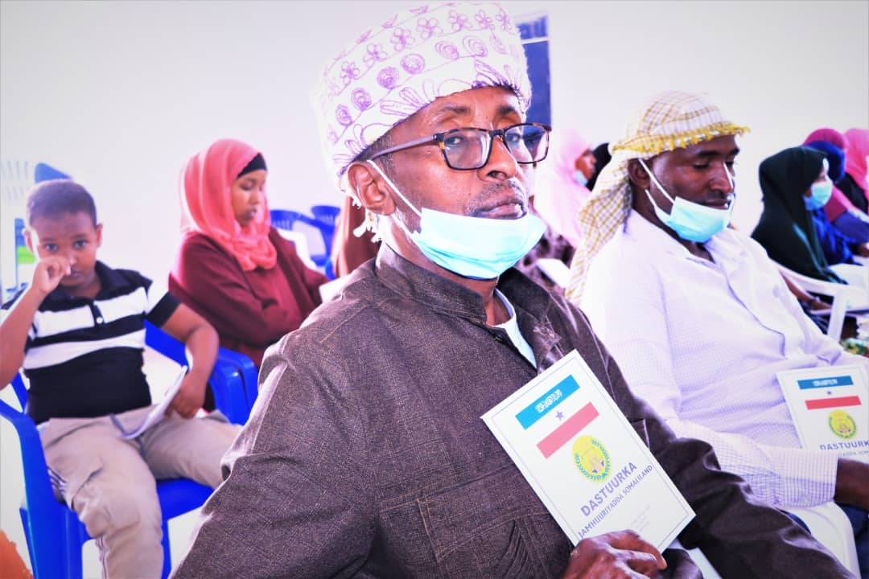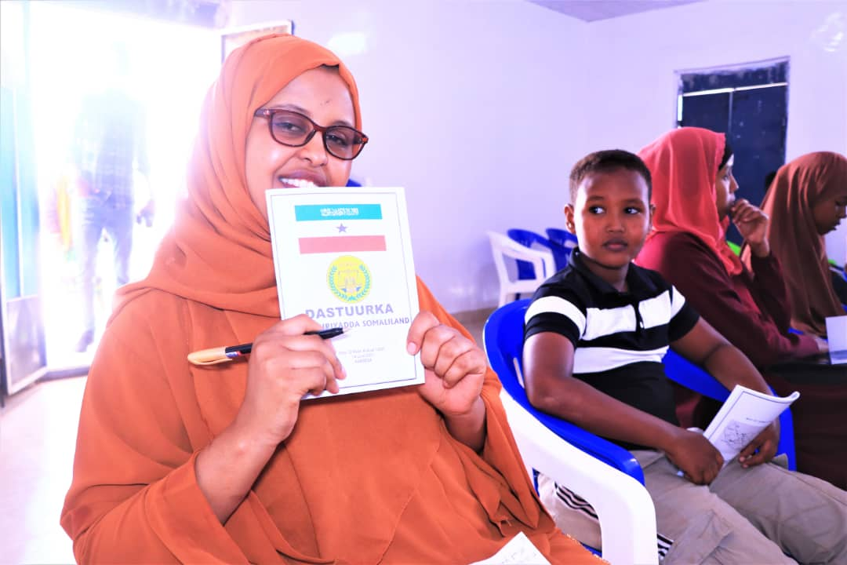

National awareness raising sessions on civic rights and constitutional obligation through stage mass media, drama, celebration national and international events

ASAL Organization collaborated with Ministry of parliamentary relation and constitutional affairs has conducted two days’ awareness raising sessions on civic rights and constitutional affairs, the awareness was held in Hargeisa and over 90 participants attended the awareness campaign.
Carry out monthly awareness raising sessions on civic and constitutional rights at community level
ASAL Youth Development Association collaborated with Ministry of parliamentary relation and constitutional affairs has conducted monthly awareness raising sessions on civic and constitutional rights at community that held on Centre for constitution and civic education and over 80 youth from different villages of Hargeisa district attended the awareness.

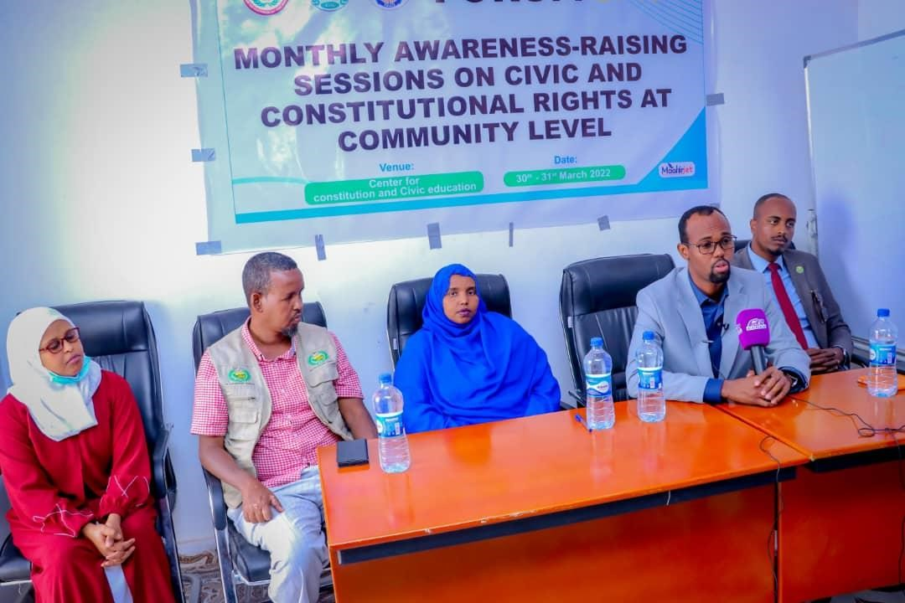
Capacity building trainings for the members of CSOs Forum/Taskforce on policy advocacy skills July 2022
ASAL Youth organization has conducted two days’ capacity building training for the members of Civil society organizations and community groups on Policy advocacy skills, at Hargeisa city.

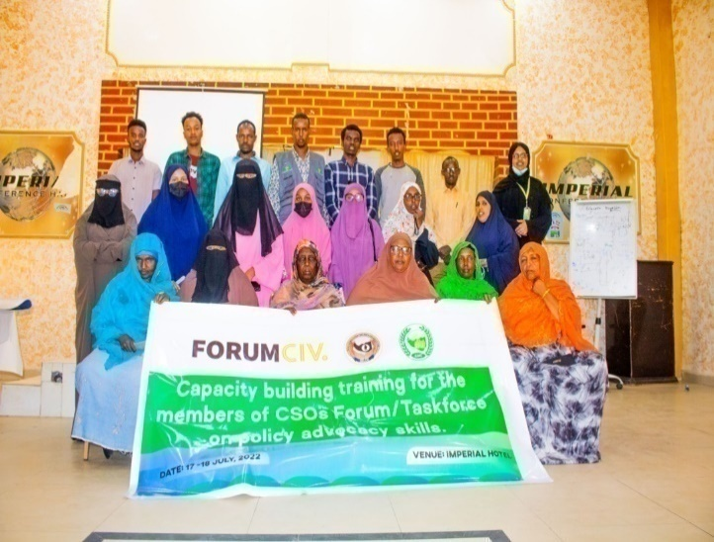

Provide legal aid support for the victims of GBVs cases through counselling and referral pathways at community level

During the months of March - June 2022, ASAL was supported and provided the legal aid assistant to the victims of GBV cases by focused the most vulnerable people such asWomen, Children, Minority, IDPs, Refugees/asylum seekers and People who have special needs. During this activity, the total of 20 Victims of GBVs Cases were received a legal aid support through counselling and referral pathways at community level.

Conduct outreach visit routines to the community centres, MCH and other public offices in the remote areas to improve awareness and influencing duty-bearers

ASAL has been Organized a various outreach-programs and visit routines to the community centers, MCH and other public offices in the remote areas to enhance community’s awareness on their civic rights and promotion of Duty bearer’s accountability in the areas of protection and social welfare at community level in Baligubadle & Balicabane.

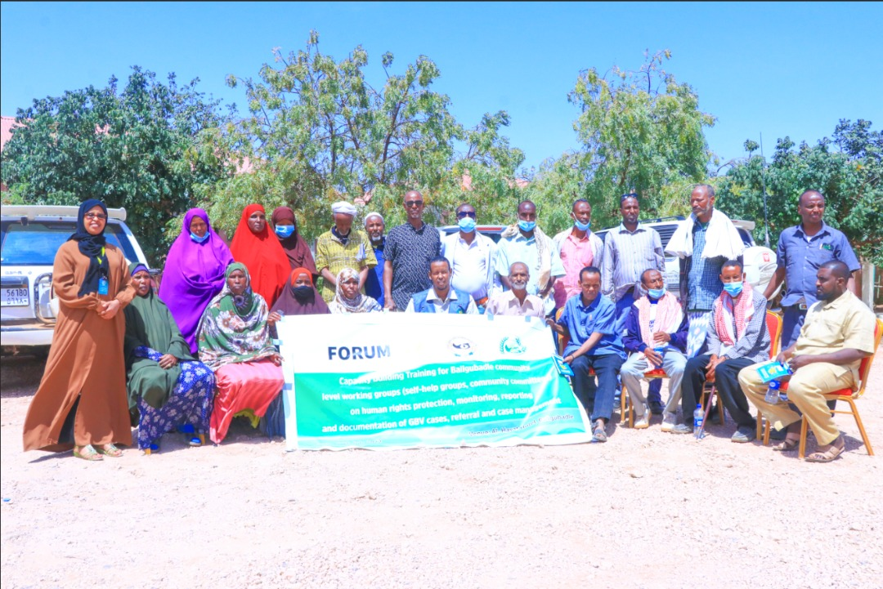

Support quarterly Coordination meeting of Civil Society to reflect and discuss democracy process, sharing information related corruptions & misuses of resources and follow-up all policy recommendations

ASAL has supported and organized quarterly coordination meeting of civil society to reflect and discuss democracy process, sharing information related corruptions and misuses of resources and follow-up all policy recommendations on 17thApril 2022. The meeting was held in Hargeisa and attended over 40 representatives from civil society. The objective of the meeting was to create platform and gathering space in order to share information and discuss the ongoing efforts to promote democracy and removed corruptions and misuse of resources.

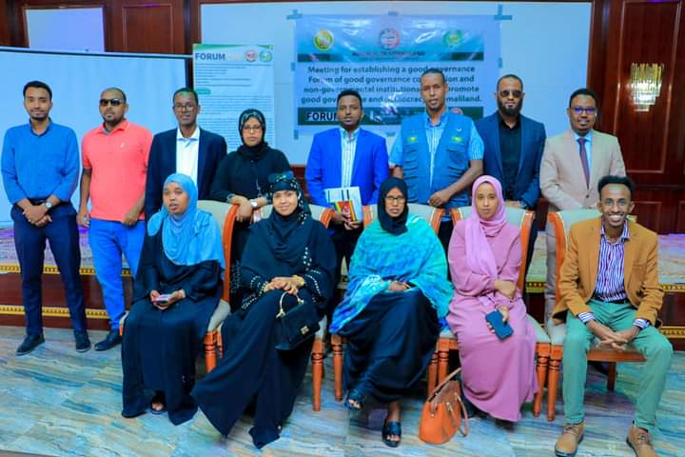

Carry-out advocacy and lobbying campaign to add Education Curriculum on civic rights and constitutional learning courses

On 10th May 2022, ASAL has organized and conducted one-day awareness workshop session on civic rights and constitutional obligations for university students in Hargeisa, the workshop was held in Hargeisa and attended over 40 students from different universities and ForumCiv monitoring officers.

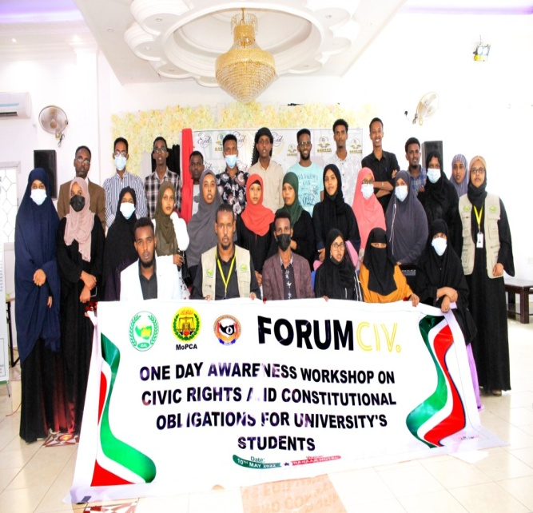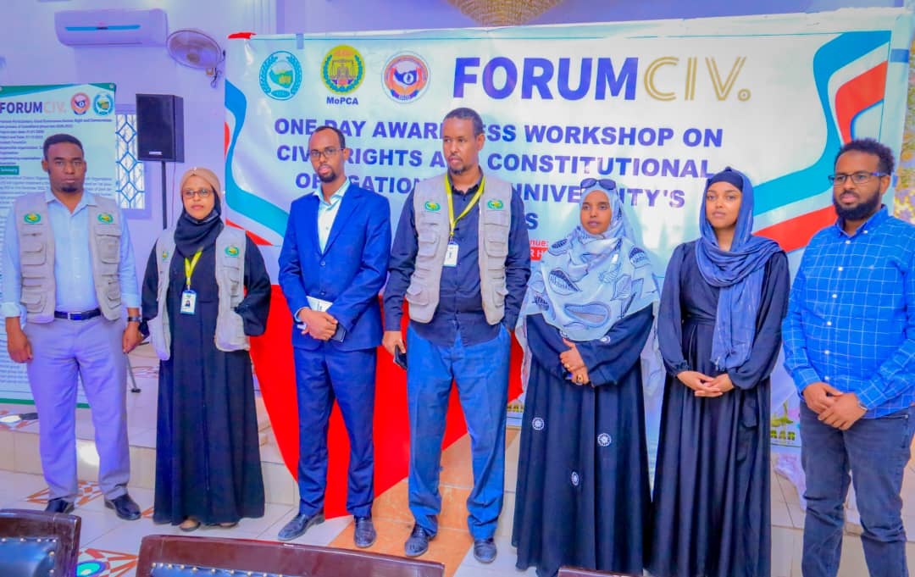

Organize Public Forums dialogue on issues of governance, public policy, decentralization, elections, and accountability of law enforcement institutions

ASAL has organized public forums dialogue on issues of governance, Public policy, decentralization, elections and accountability of law enforcement institutions, this public dialogue held in Hargeisa, and attended key actors of government, CSOs and community level working groups in some regions, the main objective of the meeting was organizing forum dialogue on issue of governance to discuss public policies, decentralizations, coming elections and to promote accountability within the public institutions and law enforcement institutions.

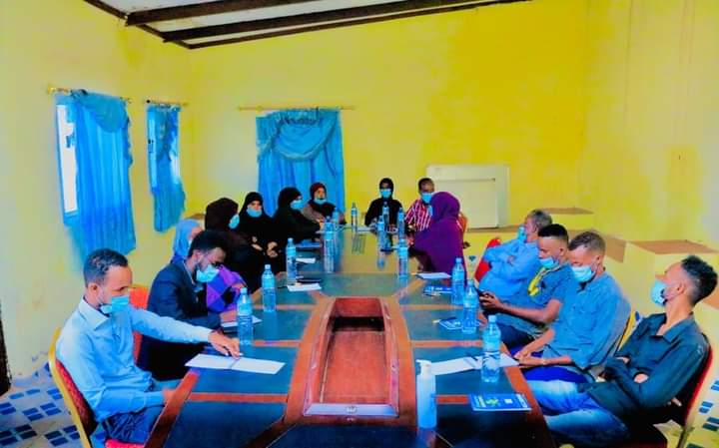

FINANCIAL REPORT FOR 2013-2022

Income from ForumCiv (Forum Syd) through Save Somaliland Children Organization 919,288.64
Total Expenditures: | $ 919,288.64

Break down by Activities

Promote Participatory, Good Governance, Human Right and Democratization process of Somaliland phase two 2020-2022 (300008807) 148,234.11

Promote Participatory, Good Governance, Human rights and Democratic System of the country 2016-2018 (300007042) 147,647.88
Strengthening Democratic and Good Governance in Somaliland Phase-II 2019 (300008187) $ 24221.2

Democracy and Women’s Human Rights Promotion project activities costs 130,787

IDPs and poor women’s basic education and job opportunity skill Phase I activities $19352

IDPs and Poor Womens Basic Education & Jop Opportunity Skill Phase II (300006453) $50,615

Provide legal aid support for the victims of GBVs cases through counseling and referral pathways at community level 12923.78

Project Laptops (3 Laptops) 2184.6

Project Equipments (Photocopy, binding, cutting and lamination Machines) 963

Transportations 58153.08

Salaries $ 283,934.86

Administrations (Communication/Outreach Costs (Internat &Telephone), Audit and Managements of Accounts) $ 30864.07

Staff capacity building 9408.06

PROJECT PICTURES
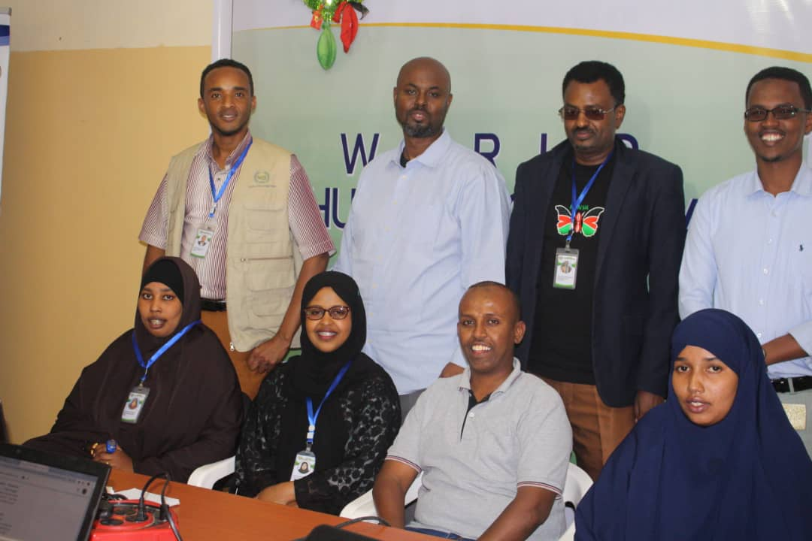
ASAL Team and Ahmed Muse from Save Somaliland Children Organization Diaspora

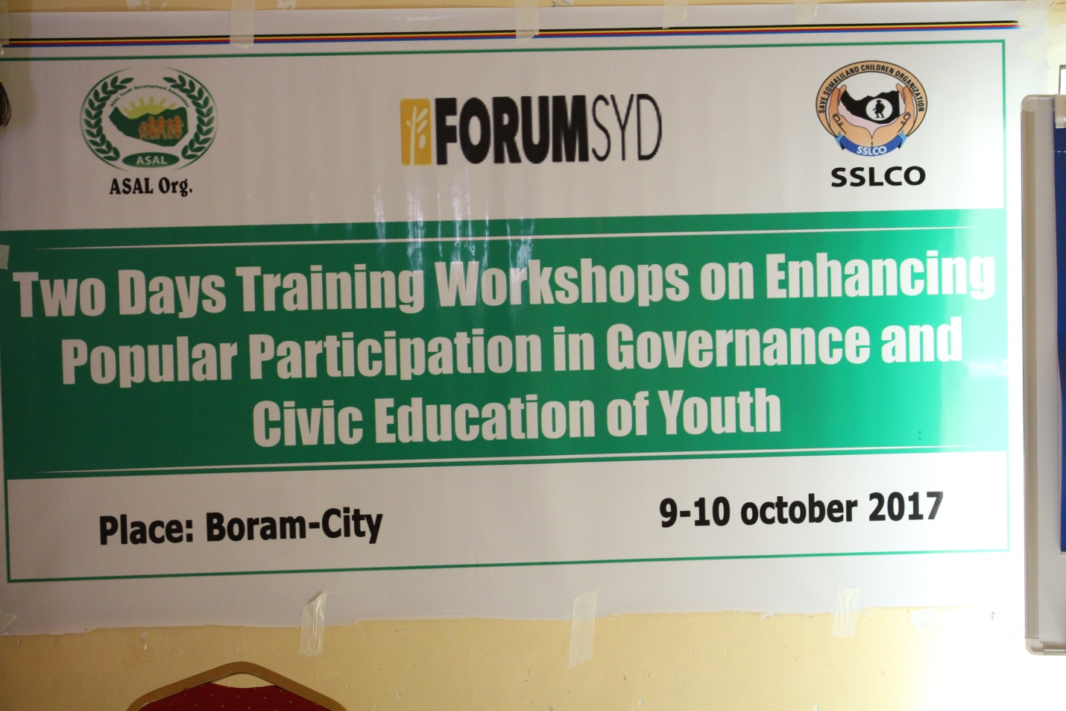

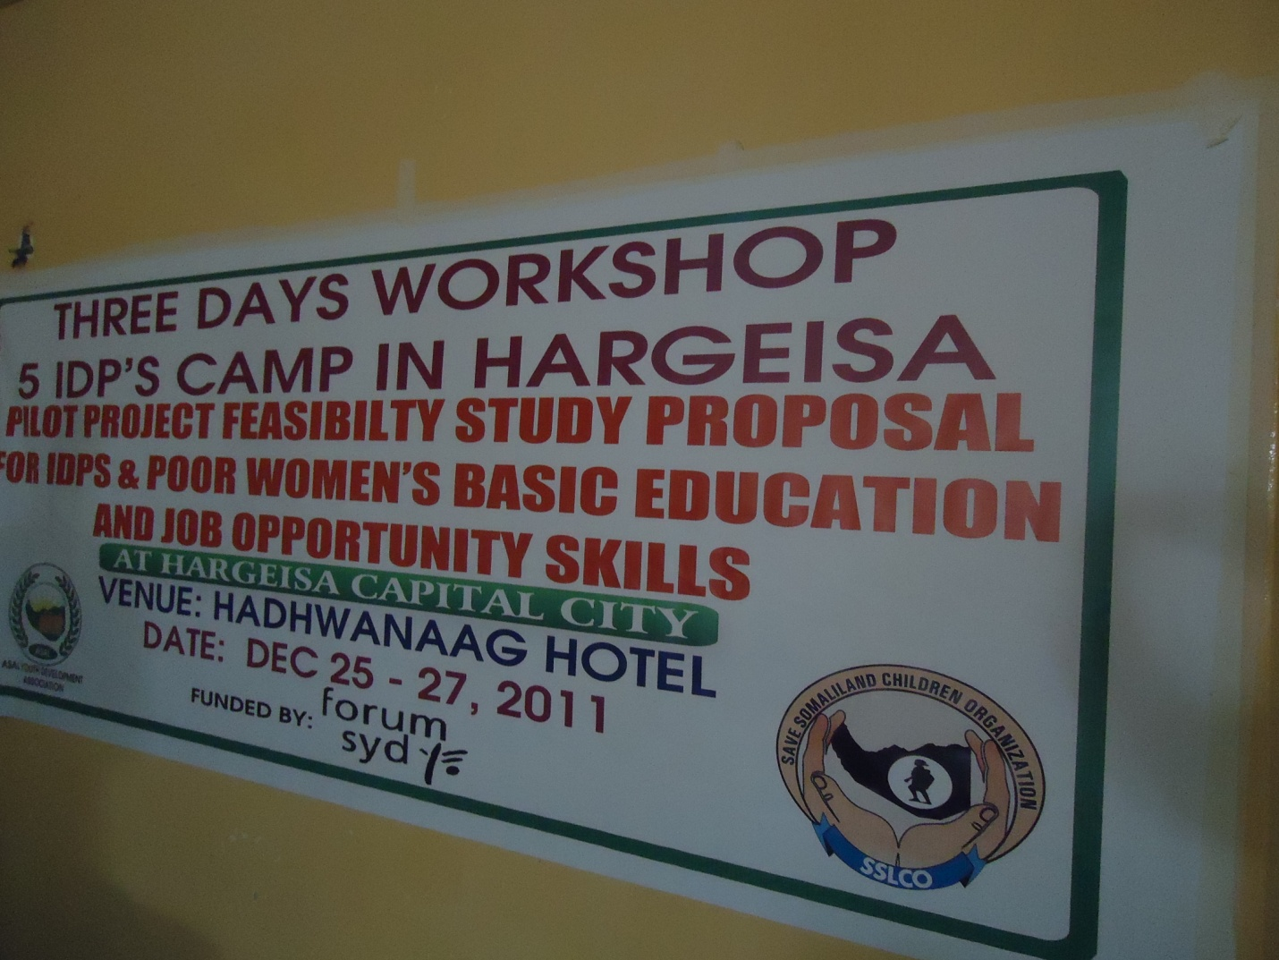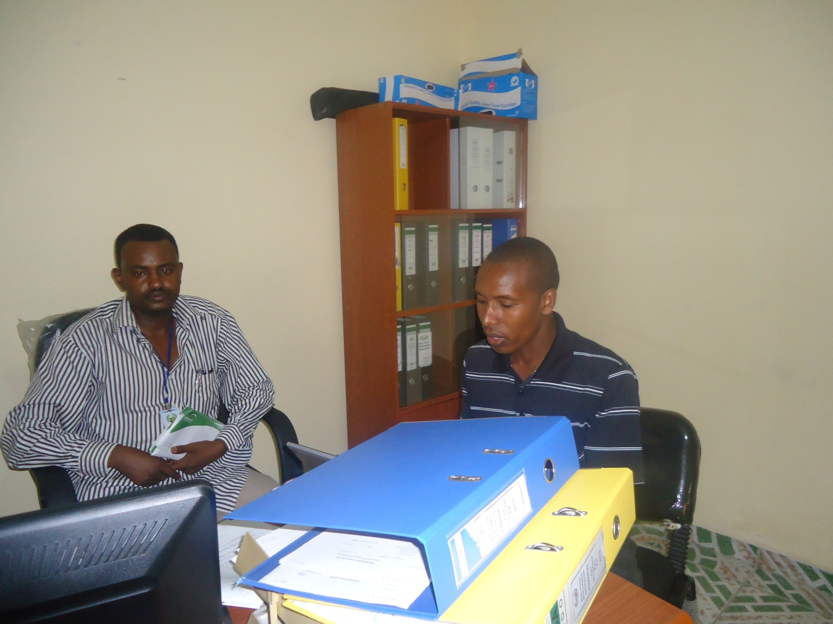

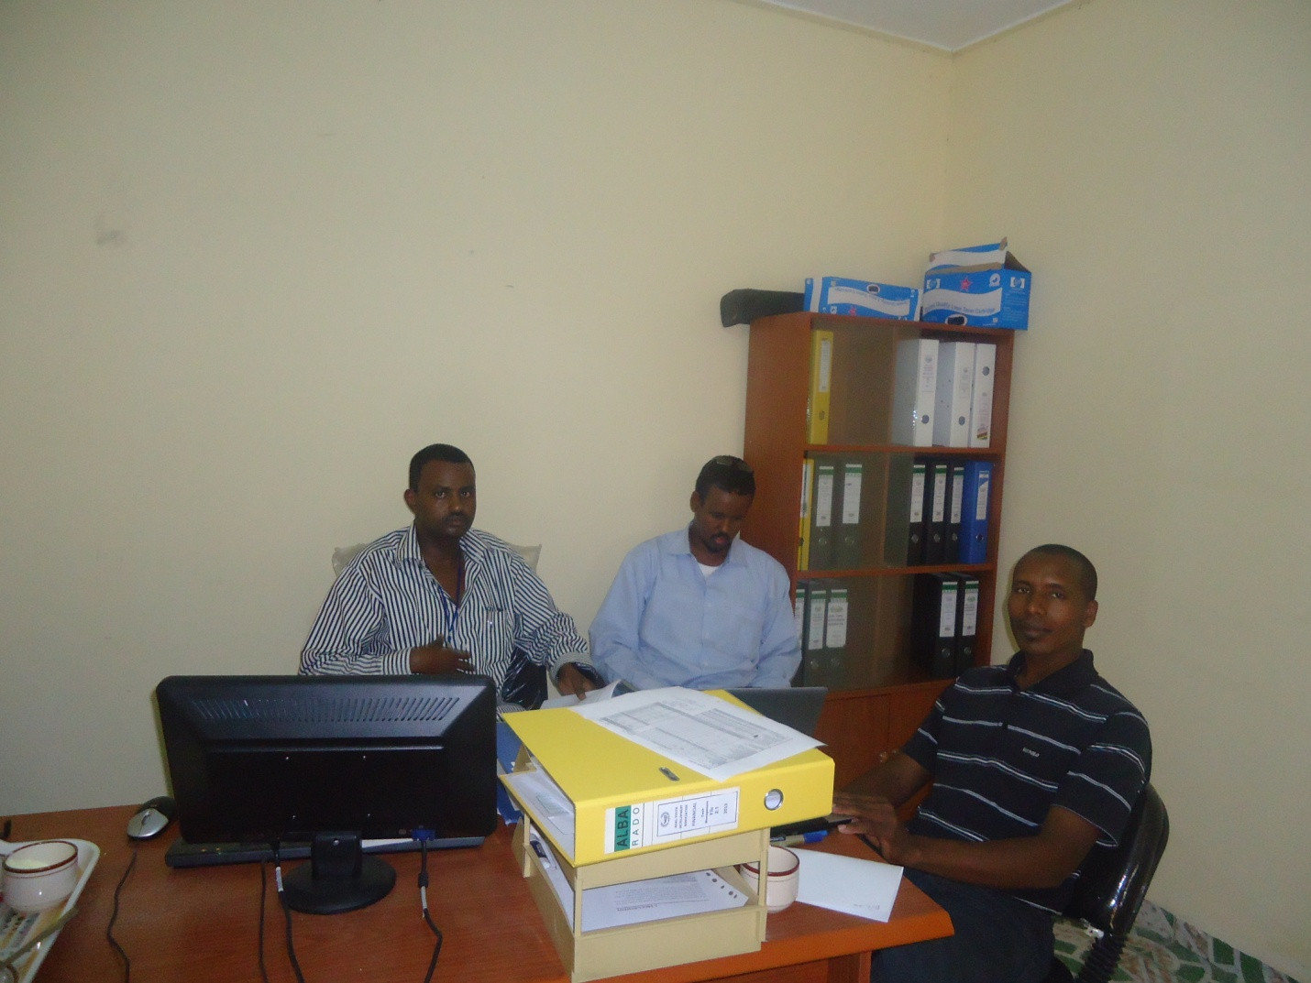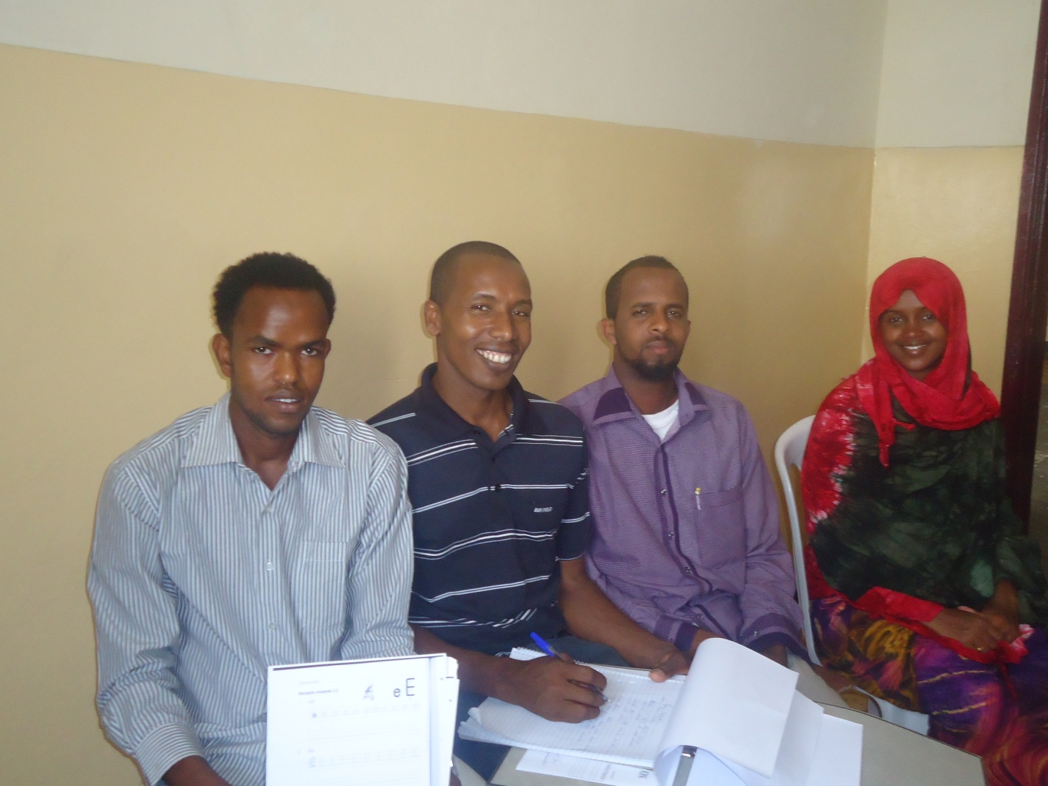

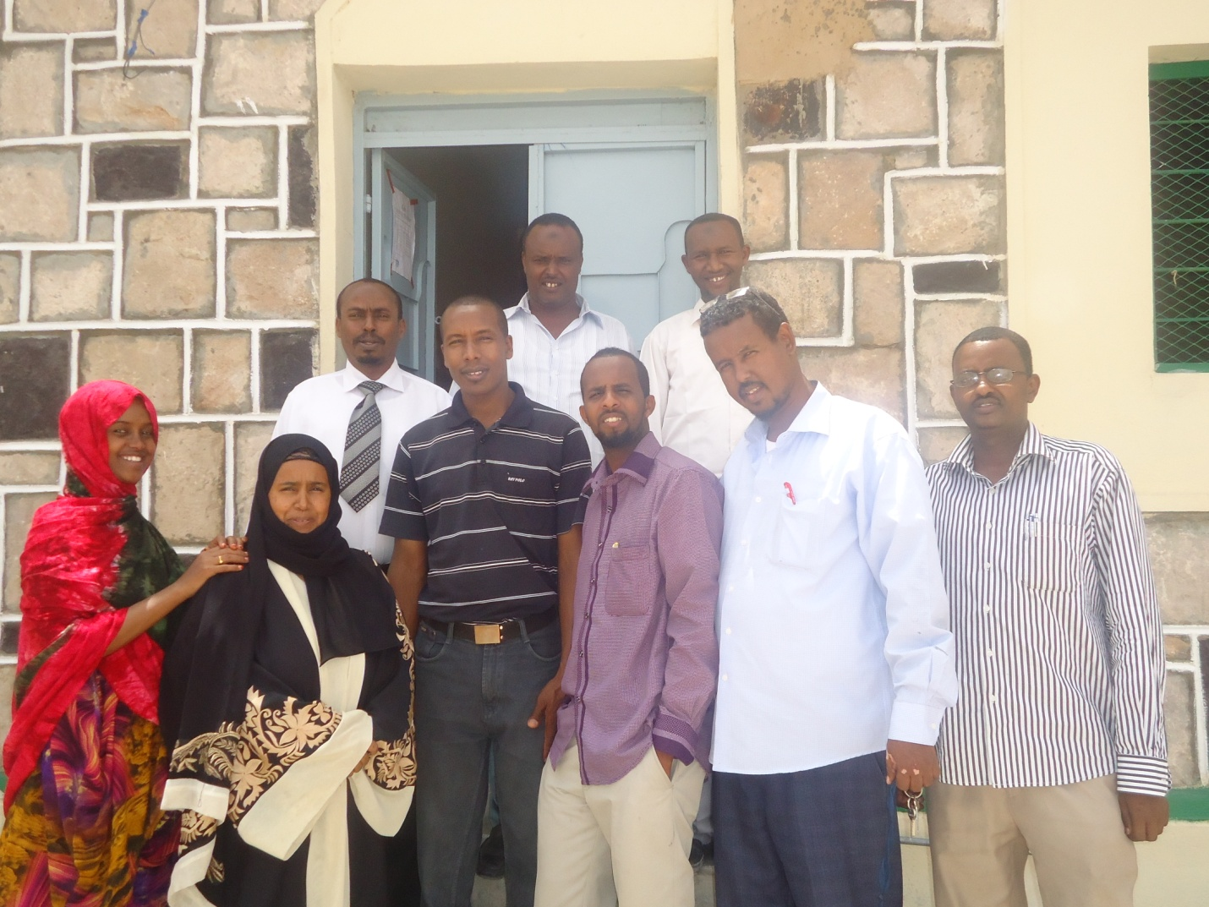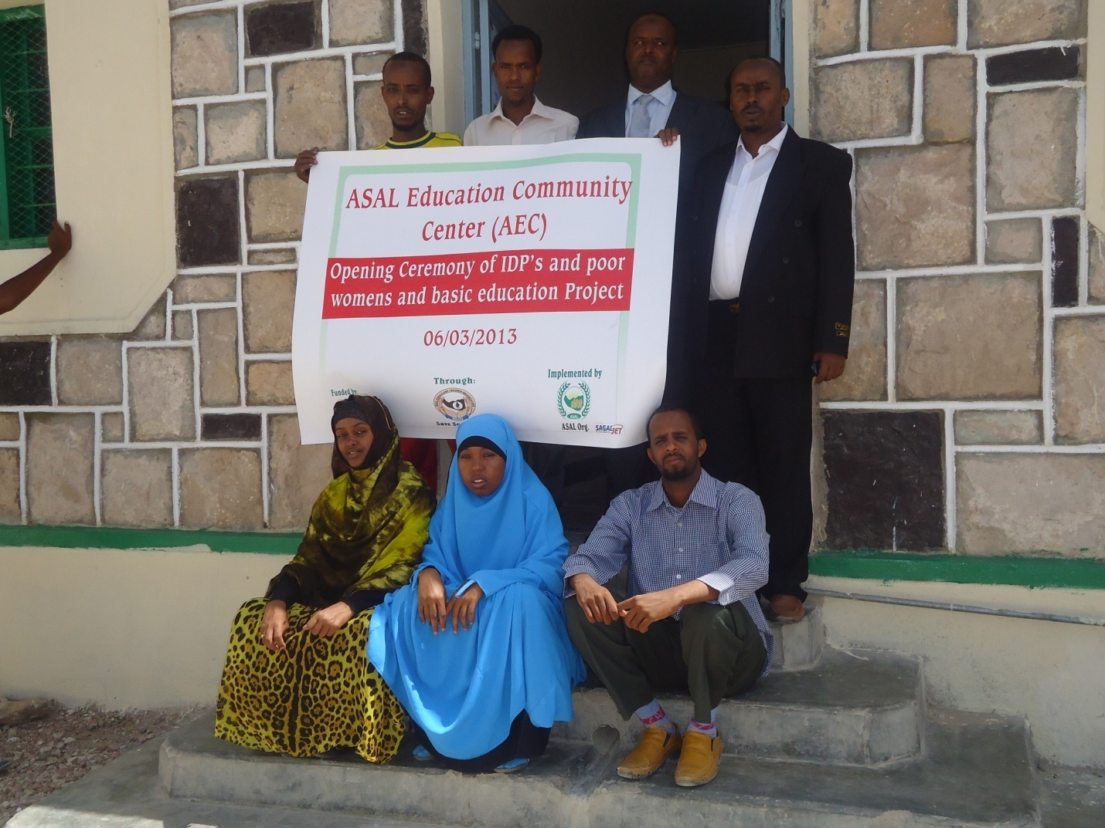

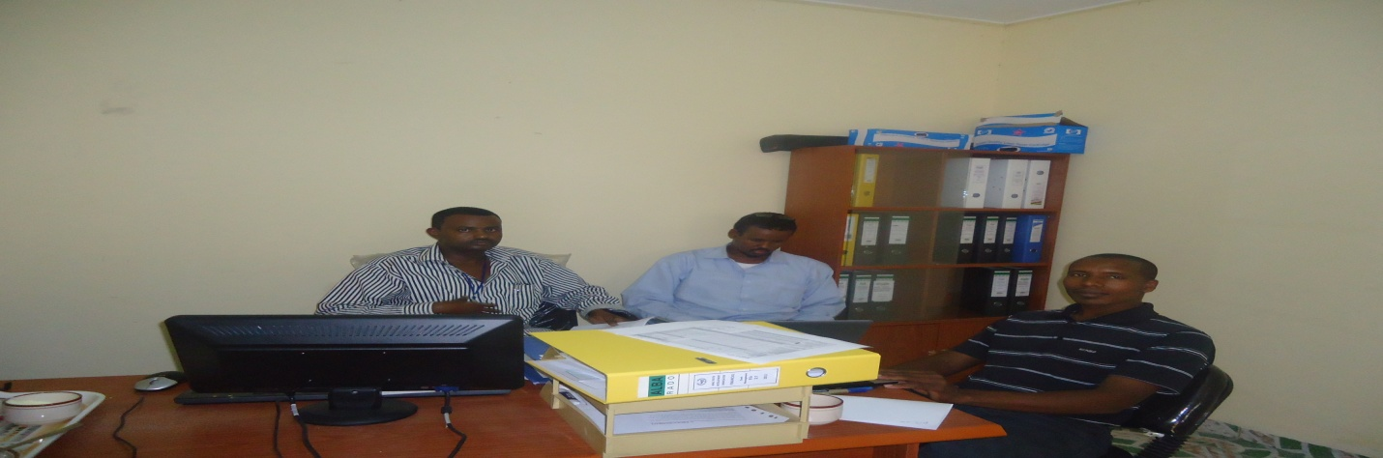 | 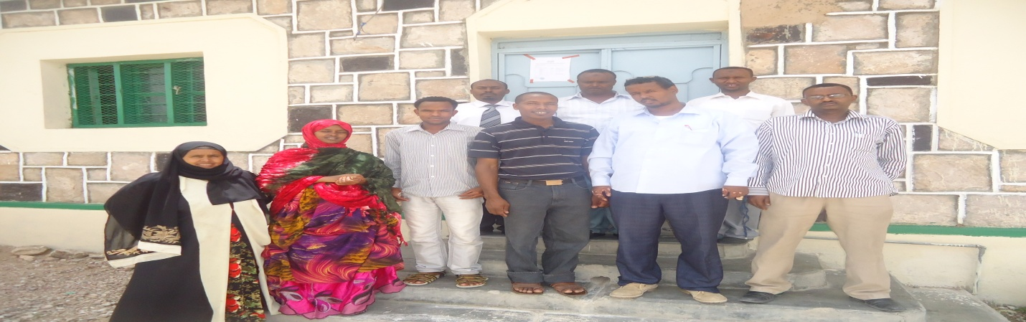
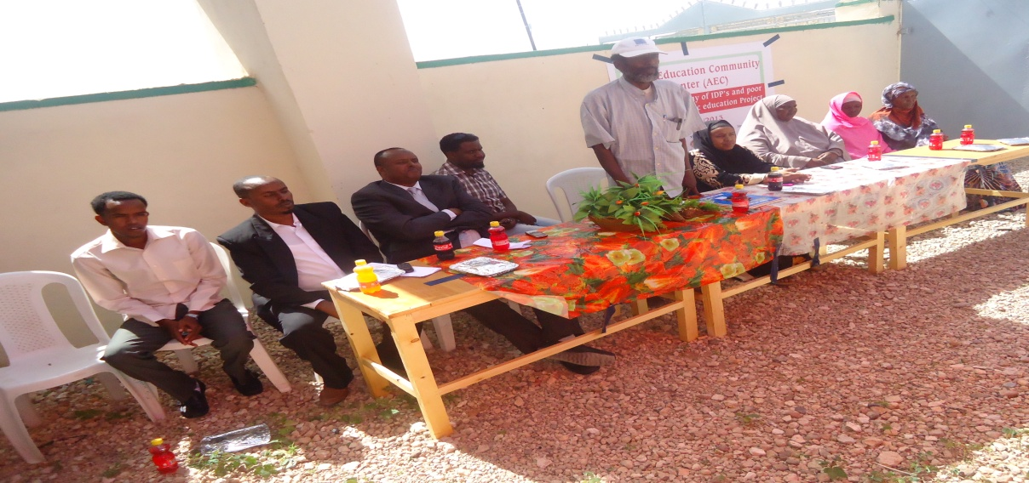 | 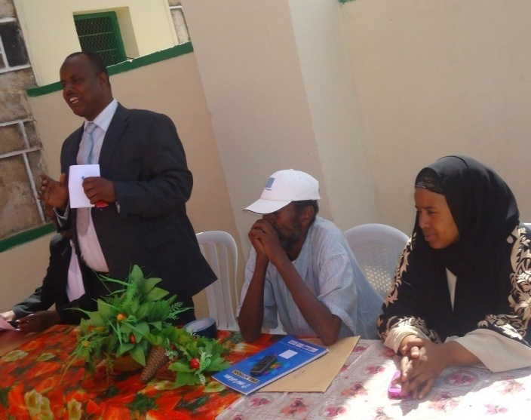
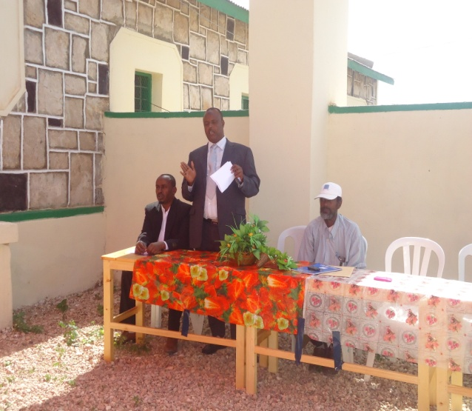 | 